

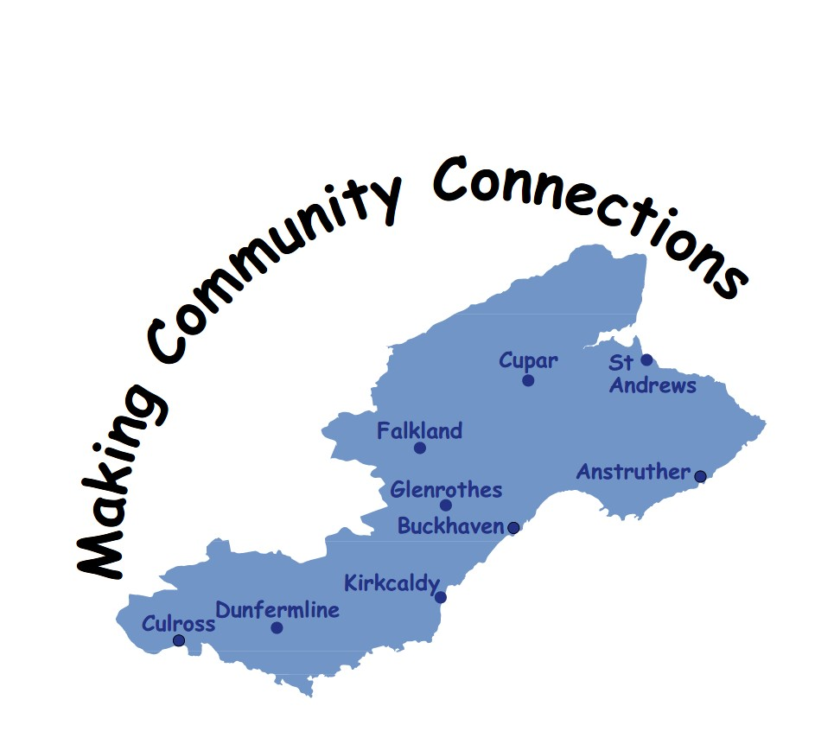

SHOPPING DELIVERY
&
DOMESTIC SERVICE PROVIDERS
+
OTHER USEFUL
INFORMATION

Fife Forum is the umbrella organisation for all elderly fora and user panels in Fife, offering information advice and advocacy for older people.

The information contained in this booklet is provided as a guide for people who may require a shopping delivery or cleaning service to assist them with their daily living.

Along with this information are details of some other organisations that may be of use to you.

This is general information to assist you only. No organisation mentioned is endorsed by Fife Forum

Assistance in Care Services 07549982245

Rate

Personal Care £16.00 per hour

Area Covered

West Fife

Disclosure Checked

Yes

We strive to provide Care and Support in a manner which respects the privacy, dignity and wishes of service users.

Payment can be made by cash or cheque.

Avenue Care Services 01764 663644

Rate £16.00 per hour

Domestic Cleaning
Shopping Delivery
Prescription Collection Service

Area Covered

Fife wide except St Andrews

Disclosure Checked

Yes

General household duties including Laundry and Bed changing.

Payment by Direct Debit, Standing Order, Cash or Cheque.

Busy B Services 01592 868589
Or 07496 676291

Rate

£9.00 per hour

Shopping Delivery
Prescription Collection
Pension Collection
Post Office Services.
Other services available per discussion

Area Covered

Central & West Fife

Disclosure Checked

Yes

Payment by cash or direct debit
Caledonian Housing Association 01382 484542

Rate

£12.95 per hour for all services

Domestic Cleaning – Vacuuming, Dusting & Polishing
One-off “Spring Clean”
Internal Windows Cleaned
Laundry & Ironing
Local Shopping
Collection of Prescriptions
Paying Bills

£10 set up fee includes personal visit

Area Covered

Newport, Tayport, Gauldry, Ladybank and Cupar

Disclosure Checked

Yes

We provide a flexible, personalised and professional service. If you would like to find out more contact our Home Help Co-ordinator for further information

Carewatch 01592 577555

Rate

Domestic Cleaning £15.95 per hour 7am to 7pm Mon to Fri only

Personal Care/Sitting Service/ Social Visits/Escort Service
£15.95 per hour or £9.40 per ½ hour 7am to 7pm Mon to Friday
£15.95 per hour or £9.40 per ½ hour 7pm to 7am Mon to Friday

£15.95 per hour or £10.50 per ½ hour 7am to 7pm Sat & Sunday
£15.95 per hour or £10.50 per ½ hour 7am to 7pm Sat & Sunday
£31.90 per hour or £21.00 per ½ hour Public Holidays

Mileage charge is £0.35p per mile.

Area Covered

Fife Wide

Disclosure Checked

Yes

Shopping delivery and other services also available contact them direct for further information.

Cleaner Connections 0800 158 8223

Rate

Domestic Cleaning – all domestic services. £9.50 per hour

Area Covered

Fife Wide

Disclosure Checked

Yes

We offer a friendly and reliable domestic cleaning service and general help around the home. We assign the same housekeeper who will attend to the needs of the client at a time and day suitable.

Payment can be by cash, cheque or standing order.

Domestic Matters 0790 159 5854

Rate

Domestic Cleaning £11.50 per hour
Shopping Delivery Not provided
Prescription Collection Not provided
Pension Collection Not Provided
Post Office Services Not Provided

Area Covered

Dunfermline through to Leven

Disclosure Checked

Yes

Will also provide oven cleaning and one-off cleaning service.

Easy Cleaners 01592 323014

Rate

A range of cleaning services are available from domestic to oven cleaning. With prices from £10.00 per hour

Area Covered

Fife Wide

Disclosure Checked

Yes
Easy-Gleam Ltd 07944458496

Rate

Domestic Cleaning - changing beds, ironing etc. £12.50 per hour for those aged 65 and over

Area Covered

Central and West Fife

Disclosure Checked

Yes
For the full range of service please contact direct or visit the website www.easygleam.co.uk.

Elite Care Scotland 01334 472834

Rate

Only domestic service when it is combined with a personal care package.

Area Covered

Fife Wide

Disclosure Checked

Yes

For a full range of services please contact direct

Fife Shopping and More 0131 618 6515
07941400753 or 07800814791
Email: brava937@yahoo.com
Rate

Shopping Delivery £8.00 to £10.00 per shop
One to One outing £14.00 for 1st hour then £5 per ½ hour
Prescription Collection £4.00
Pension Collection £5.00
Paying Utilities £5.00 per 4 week period
Cleaning £11.00 for 1st hour, discount for 2nd
Bank Deposit/Withdrawals As part of one-2-one

Area Covered

All areas considered.

Disclosure Checked

Yes

Payment by cash or standing order.

Mileage rates may apply depending on Location.

Contact direct for further information.

Fife Shopping and Support Services 01592 653344

Rate

Shopping £10.00 - £12.00
Shopping +Pension, Bills etc. £6.00 - £14.40 if combined
Pension/Post Office Services £6.00
Prescription Collection only £4.80
Domestic Cleaning £12.00 per hour
Bank Services £6.00
Befriending &
Companion Service £12.00 + mile @45p per mile
Garden/Home Maintenance £14.00 per hour

Discounts apply when using more than one service.

Area Covered

Fife Wide except St Andrews

Disclosure Checked

Yes

Staff will assist with completion of the shopping lists and putting the groceries away.

Payment by cash or standing order.

Charity Registered. Not for profit organisation.

First Domestic Ltd 01383 736922
Or 0774 508 5970

Rate

Shopping Delivery £6.00
Prescription Collection £3.00
Pension Collection £3.00
Post Office Services £3.00
Domestic Cleaning £10.00 per hour

Area Covered

Ballingry, Dunfermline & Oakley

Disclosure Checked

Yes

Service available 24 hours 7 days a week contact direct for any additional information

Guardian Peace of Mind Services 07462237437

Rate

Shopping Delivery Service £14.00 per hour

Cleaning, cooking, property maintenance, decorating, gardening, DIY & companionship £14.00 per hour.

Area Covered

Dunfermline and surrounding area.

Disclosure Checked

Yes

Payment is by direct debit.

Got it Covered 07581367278
Rate

Domestic Cleaning – Dusting, Hoovering, Cleaning inside of windows, Kitchen and Bathrooms cleaned, all general cleaning duties £11.50 per hour

Area Covered

West Fife

Disclosure Checked

Yes

Payment by cheque or standing order.

Jean Nail Cutting Service 07934197854

Nail cutting service for both hands and feet in the comfort of your own home, Care Home & Sheltered Housing etc for anyone over the age of 18 years.

Rate

£15.00 for each individual treatment (Hands or Feet).
Area Covered
Fife Wide

Disclosure Checked

PVG Membership

Payment by cash when treatment completed.

Jill of All Trades 07990807478

Rate

Day to day cleaning, spring clean, clear unused rooms, storage solutions and help to dispose of unwanted items.

Flat rate of £15.00 per hour charged. Slots of 20 or 30 minutes can be arranged and charged pro-rata.

Area Covered

North East Fife (Wormit based).

Disclosure Checked

Yes

Payment by cash, cheque or bank transfer – daily, weekly or monthly.

Companionship or outings also offered petrol costs are included in the hourly rate.

Karen’s Chores 01383 831103

Rate

Domestic Cleaning £11.50 per hour

Area Covered

Kelty, Cowdenbeath and Dunfermline

Disclosure Checked

Yes

Clients must supply their own cleaning materials

Kenylink Services Ltd 01592 651650 or 07846032164

Rate

Cleaning £15.83 per hour

Area Covered

East, West and Central

Disclosure Checked

Yes

Contact direct for further information

KD Cleaning Services 07759 771 508

Rate

Domestic Cleaning £10.50 per hour

Area Covered

Dunfermline and surrounding areas and up to Glenrothes

Disclosure Checked

No

Contact direct for any further information

Like2Care Limited 01383 621462

Rate

Personal Care in your home Monday-Friday £16.00 per hour
Personal Care in your home Saturday-Sunday £17.00 per hour
Domestic Cleaning £13.00 per hour
Escort into the Community £13.00 per hour
Prescription Collecting Service £4.00 + mileage £0.40 per mile
Post Office Services £4.00 + mileage £0.40 per mile

Area Covered

Dunfermline, Rosyth & Kirkcaldy

Disclosure Checked

Yes - PVG

All our staff have undertaken training including Good Communication, Administration of Medication, Equality and Diversity Awareness and Palliative Care. Our staff are friendly, experienced and reliable and always ready to help.

Monthly payment by cheque, standing order or banks transfer.

Oran Homecare Ltd 01334 652987

Rate

Shopping Delivery £15.00 per hour
Domestic Cleaning + shopping £15.00 per hour
Pension Collection Not given
Post Office Service Not Given

Area Covered

Fife Wide

Disclosure Checked

Yes

Mileage rates may apply for outlying clients.

Paramount Care Agency 01592 266711

Rate

Personal Care £15.60 per hour (Mon – Fri) 8 am – 4pm, £18.50 4pm – 8am
Personal Care £21.00 per hour (Sat-Sun)
Public Holidays – please contact direct for cost

Area Covered

Burntisland, Buckhaven, Glenrothes, Kinghorn, Kirkcaldy, Leslie & Leven

Disclosure Checked

Yes

Contact direct for further information

Perfect Clean 07708484286

Rate

Domestic Cleaning £12.00 per hour
One off cleaning, curtain & bed changing, inside windows cleaned, ironing etc.

Area Covered

Dunfermline, Crossgates, Rosyth, Inverkeithing and Dalgety Bay

Disclosure Checked

Yes

Staff will assist with putting the groceries away.

Range of other services available e.g. curtain changing, ironing, one of clean etc. Contact direct for further information.

Payment by cash or Bank transfer.

Shine Time Cleaning 01592 569851
Or 0759 189 0766

Rate

Shopping Delivery £12.00 per hour
Prescription Collection £12.00 (min 1 hour)
Cleaning £12.00 per hour (min 1 hour)

Ironing, oven and window cleaning, changing beds etc also available.
A £0.20p per mile mileage charge is also payable

Area Covered

Central Fife

Disclosure Checked

Yes

Staff will assist with completion of shopping lists, put shopping away.
Carpet cleaning also available.

Contact direct for any further information.
Shopping Delivery Service 0751 404 2751

Rate

Shopping Delivery £8.00 max per shop
Prescription Collection £0.00 included with shopping
Pension Collection £0.00 included with shopping
Post Office Services £0.00 included with shopping

Area Covered

East Fife

Disclosure Checked

Previous enhanced disclosure

Payment by cash on the day.

Spotless Team 07989 301521

Area Covered

St Andrews to Tayport & Crail and Anstruther

Rate

£12.50 per hour is using your materials
£14.50 per hour if supplying materials
Washing and shopping service can also be provided.

Disclosure Checked

This is a family business; the husband and wife are disclosure checked 2 other family members are not.
Stacey 07595 312810

Area Covered

Levenmouth to St Andrews

The Good Care Group Scotland 0131 3413 654

Rate

From £1250 per week (70 hours of care).

Provision of 24 hour live in care in your own home.

The Good Old Fashioned 01383 320570
Housekeeping Co or 0787 649 4384

Rate

Shopping Delivery £13.00 per hour
Prescription Collection £13.00
Pension Collection £13.00
Post Office Services £13.00
Domestic Cleaning £13.00 per hour
Discount is available if a combination of services being used.

Area Covered

West Fife

Disclosure Checked

Yes

Contact direct for any additional information

Time for You (Fife) Ltd 0800 695 4435

Rate

Housekeeping including ironing, changing beds etc. £11.95 per hour. Will also take client out to shops, make tea etc.

Area Covered

Fife Wide

Disclosure Checked

Yes

Payment by cash on the day.

RVS Good Neighbours 01592 269654
Rate

£0.60 pence per mile to cover cost of transport.

Area Covered

Fife Wide

Disclosure Checked

Yes

They will only provide a one to one escorting service to the shops.
Iceland Frozen Food Stores will also provide a home delivery service.
Simply shop in store in the normal way, spend £25 or more and show your Bonus Card at the checkout. Choose a time slot for your delivery, and leave the rest to us!
So how does it work?
We'll store your shopping in our freezer and chiller areas until it's ready to be delivered. Then one of our temperature controlled vans will deliver it in tip-top condition direct to your door!
Registering for Home Delivery is easy! Just ask at the checkout for a Bonus Card registration form. Once you've filled the form in with your details, hand it back to the cashier and every time you shop, we'll know exactly where to deliver your shopping.
Handy tip - look out for the Home Delivery board as you go into the store which shows available delivery times.
On-line shopping delivery is available if you or someone you know has access to the internet from:

ASDA http://www.asda.co.uk/corp/home.html

TESCO http://www.tesco.com/

SAINSBURY http://www..sainsburys.co.uk/shop/gb/groceries

There will be a delivery charge associated with these.

Chilled and Frozen foods can be obtained from the following:

Oakhouse Foods 0800 917 9338

Wiltshire Farm Foods 01764 655859

The following pages list other organisations that you may find useful to you.
Name | Telephone Number | Email Nº / Text Phone / Website
Advocacy for Older People in Care Homes & Community Hospitals (FF) | 01592 643743 | Specifically for older people who are either resident in a care home or who are patients in a community hospital and meeting the eligibility criteria.
Age Scotland Advice – Scottish Helpline for Older People | 0800 12 44 222 | Text phone: 0845 226 5851
Age UK | 0800 678 1174
Alzheimer Scotland Dementia Helpline | 0808 808 3000
Attendance Allowance | 08457 12 34 56 | Text phone: 0800 24 33 55  Website: www.direct.gov.uk/pensions
Blairhall Senior Citizens | 01383 850821
Blue Badge Renewal | 03451 55 00 66
British Red Cross | 01592 770459
Bums Off Seats – Fife Walking Initiative | 01592 583343 | Email: vivienne.mcniven@fife.gov.uk
Carers Scotland | 0808 808 7777
Circles Network – Professional and Independent Advocacy Service providing issue-based Individual and Collective Advocacy Support | 01592 645360
Citizens Advice & Rights Fife | 0845 1400 095
Concessionary Travel (My Fife card) | 03451 55 55 55  Ext 444381  01592 583370
Contact the Elderly in Scotland | 01505 874412
Cruse Bereavement Care Fife | 08456 06 64 89
Dalgety Bay Senior Citizens Club | 01383 823167
Deaf Communication Services – Fife Council | 01592 583341 | Minicom 01592 583265
Dental Helpline | 08450 63 11 88
Dial a Ride | 03451 55 11 88 | This is a free shopping service for people who have difficulty using conventional public transport. Trained staff pick up passengers from their doors who are then driven to one of a choice of Town Centre destinations. For further information on how to use this service please contact the number provided.
Disability Living Allowance | 08457 12 34 56 | Text phone: 0800 24 33 55  Website: www.direct.gov.uk/pensions
Disabilities Fife | 01592 203993 | Mobile: SMS Text 07841504318  Email: chair@disabiltiesfife.org.uk
East Neuk Frail Elderly | 01333 311837 | Email: enproject@btinternet.com
Energy Saving Scotland Advice Centre | 0800 710 1016 | Email: energyadvice@changeworks.org.uk
Energywatch | 0800 710 1016
Fairprice Mobility Scotland | 01592 652244 | Disability Equipment (Manufacturers & Suppliers)
Fife Carers Centre | 01592 205472 | Email: centre@fife.carers.net
Fife Care & Repair | 01592 631661 | Email: careandrepair@kingdomhousing.org.uk
Fife Cares – Home Safety | 03451 551503 | Email: admin.fifecares@fife.gov.uk
Fife Council Money Advice | 01592 583123 | Email: money.advice@fife.gov.uk
Fife Council Main Switchboard | 03451 55 0000
Fife Council  Social Work Contact Centre  Out of Hours | 03451 551503  03451 550099 | This is the number for all Social Work services.  17.00-9.00 am Mon to Fri, all weekend and public holidays
Fife Day Care Services Ltd | 01592 782889 | Email: fifedaycare@gmail.com
Fife Footcare | 0800 389 6046 | Email: james@fifevoluntaryaction.org.uk
Fife Forum | 01592 643743 | Email: info@fifeforum.org.uk  Website: www.fifeforum.org.uk
Fife Pakistan Assoc |  | Email: fifepakistanassociation@yahoo.co.uk
Fife Sensory Impairment Centre | 01592 644979 | Email: info@fsbinsight.co.uk
Fife Shopmobility | 0844 3356414 | Glenrothes - option 1  Kirkcaldy - option 2  Dunfermline - option 3
Fife User Panels | 01592 643743 | Email: julia@fifeforum.org.uk
FRAE Fife | 01592 204005 | Email: info@fraefife.co.uk  Web: www.fraefife.co.uk
Furniture Plus Ltd | 01592 654546 | Email: enquiries@furnitureplus.org.uk
Housing Energy Management Service | 03451 55 55 55  Ext 473412
Local Area Coordinator’s  (Fife Forum) | 01592 643743 | www.fife-elderly-directory.org.uk  An online directory of services for older people
Macmillan Cancer Support | 0800 500 800
Mailing Preference Service | 0845 703 4599
NHS 24 | 08454 24 24 24
Pension Credit /State Pension | 08456 06 02 65 | Text phone: 0800 169 0133  Website: www.direct.gov.uk/pensions
Police Scotland | 101 | Non-Emergency calls and business  Emergency calls 999
Queen Margaret Hospital | 01383 623623
Ring and Ride | 03451 55 11 88 | This is a door to door service that you must call and book in advance. The bus will call at your door and will take you anywhere within the local operating area.  Currently operating in:  - Kirkcaldy  - Levenmouth (Leven/Buckhaven/Methil/ Methilhill, Kennoway, Windygates)  - Dunfermline including Rosyth  - Glenrothes
Royal National Institute of the Blind | 0303 123 9999 | Text phone: 18001 0845 766 9999
Scottish Fire & Rescue Service | 0800 0731 999 | Keep you and your loved ones safe from fire - get your free home fire safety visit today.  We'll help you sort out a fire escape plan and fit smoke alarms free of charge if your home requires them.
Shelterline | 0808 800 4444
Tax Help for  Older People | 0845 125  9732
Tayport Old Peoples Club | 42 Elizabeth Street Tayport DD6 9LT
Telephone Preference Service | 08450 70 07 07
Tenants Improvement Grant Scheme | 01334 412867
Trading Standards Service – Fife Council | 01592 583141
U-Switch | 08453 45 12 96
Victoria Hospital | 01592 643355
Will Writing Company | 0844 412 0776
RVS–Good Neighbours Home Support Project | 01592 269654

Anyone wishing further information or assistance with the information contained or information relating to the services of Fife Forum should contact us by writing to us at the address overleaf or by calling either of the Freephone numbers given.

Office 1-2 Fraser Buildings
Millie Street
Kirkcaldy
KY1 2NL

Freephone 0800 032 4595
0800 032 4596

Email info@fifeforum.org.uk

Website www.fifeforum.org.uk

Scottish Charity Number SC022596

 Feb 2018

