

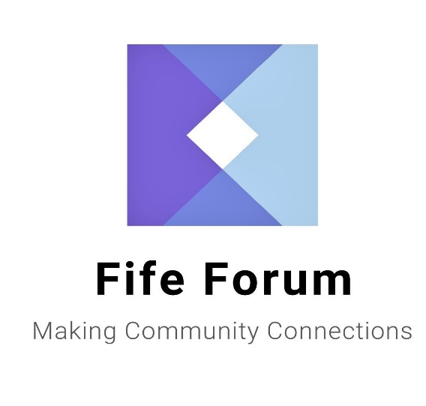

SHOPPING DELIVERY
&
DOMESTIC SERVICE PROVIDERS
+
OTHER USEFUL
INFORMATION

Fife Forum is the umbrella organisation for all elderly fora and user panels in Fife, offering information advice and advocacy for older people.

The information contained in this booklet is provided as a guide for people who may require a shopping delivery or cleaning service to assist them with their daily living.

Along with this information are details of some other organisations that may be of use to you.

This is general information to assist you only. No organisation mentioned is endorsed by Fife Forum

Ageless Companions 01592 396326
or 07728 596126
Rate

Shopping Delivery Service £17.95 per hour for all services
Prescription Collection Service
Post Office Services
Befriending/Companion Service

Area Covered

Fife Wide

Discloser Checked

Yes

Staff will assist with completion of shopping lists and putting the groceries away.

Staff will assist the client in light housekeeping duties during their Companion hours.

Mileage is calculated at 50p per mile. Mileage is paid only when Companion is with the client.

An invoice is issued every 4weeks. Payment can be made by BACS transfer, Credit/Debit card or cheque.

All staff have had Adult Protection Training; Covid-19 Awareness Training and are Dementia Friends having undertaken Dementia Awareness Training.

Assisted Services 07549982245
0r 01592 775261
Rate

Personal Care £18.88 per hour Monday-Friday
£23.67 per hour Saturday-Sunday

Area Covered

West Fife

Disclosure Checked

Yes

We strive to provide Care and Support in a manner which respects the privacy, dignity and wishes of service users.

Payment can be made by cash or cheque.

Avenue Care Services 01383 326401

Rate £20.00 per hour

Domestic Cleaning
Shopping Delivery
Prescription Collection Service

Area Covered

Fife wide except St Andrews

Disclosure Checked

Yes

General household duties including Laundry and Bed changing.
Payment by Direct Debit, Standing Order, Cash or Cheque.

Bloomin’ Braw (Garden Maintenance) 07393 411430

Rate
Jobs are completed to a high standard at reasonable prices. All services come with a smile. Call Dylan now to book your personalised and free, no obligation quotation.

Area covered
Bloomin’ Braw is a garden maintenance service, based in Benarty, Kirkcaldy, Dunfermline; and anywhere in between.

PVG Checked
Yes and Dylan has experience working with elderly and vulnerable people.

Payment can be made either with cash or bank transfer.

Blue Star St Andrews Ltd 07967025121

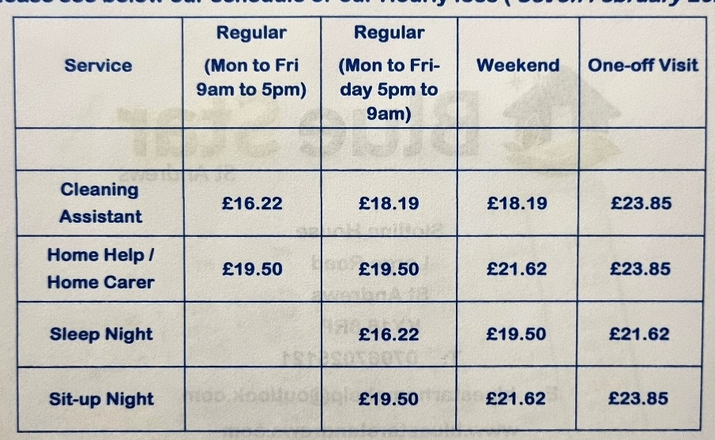
Area Covered

St Andrews and surrounding area, East Neuk villages and Howe of Fife.

Disclosure Checked

Yes

Constance Care 01592 577555

Rate

Personal Care Only £18.88 per hour Monday – Friday
£23.87 per hour Saturday - Sunday

Area Covered

Glenrothes, Kirkcaldy and Levenmouth, Dalgety Bay.

Disclosure Checked

Yes

Personal Care/Sitting Service/ Social Visits/Escort Services also available contact them direct for further information.

Caroline Inch 07593416528

Rate

£25.00 Footcare Services only.

Area Covered

Kirkcaldy, Dunfermline & surrounding area.

Possible mileage charge.

Disclosure Checked

Yes PVG
Central Fife Companions 07956666275

Rate

£16.00 per hour for all services.

Shopping Service, Prescription Collection, Post Office Services,
Befriending/Companion Service

Mileage Charge £0.50p per mile.

Area Covered

Fife Wide
Disclosure Checked

Yes

Crisscross Companion 01333 279328
Or 07580006161
Rate

From £13.50 per hour.

Shopping Service, Appointments i.e. Doctor, Hospital, Chiropody and Hairdresser. Staff will assist in light Housework.

Area Covered

North East Fife, St Andrews & East Neuk.

Mileage charge of 55p per mile.

Disclosure checked

Yes PVG

Domestic Matters 07901 595854

Rate

Domestic Cleaning £16.00 per hour

Area Covered

Dunfermline through to Leven

Disclosure Checked

Yes

Will also provide oven cleaning and one-off cleaning service.

Elite Care Scotland 01334 476262

Rate

£22.00 per hour Monday – Friday
£23.32 per hour Saturday – Sunday
£17.61 per hour Sleepover

Only personal care packages.

Area Covered

Fife Wide

Disclosure Checked

Yes

For a full range of services please contact direct

Fife Shopping and Support Services 01592 653344

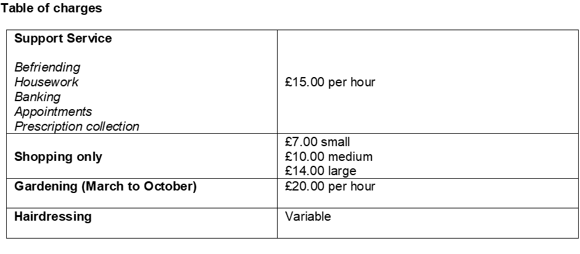

There is a charge for mileage from home to home at 45p a mile and you will be required to pay for any meals or refreshments whilst out.

Area Covered
Fife Wide

Disclosure Checked

Yes

Staff will assist with completion of the shopping lists and putting the groceries away.

Payment by cash or standing order.

Charity Registered. SC042624 Not for profit organisation.

First Domestic Ltd 01383 736922
Or 0774 508 5970
Rate

Shopping Delivery £6.00
Prescription Collection £3.00
Pension Collection £3.00
Post Office Services £3.00
Domestic Cleaning £10.00 per hour

Area Covered

Dunfermline, Carnock, Cairneyhill, Hill of Beath & Oakley

Disclosure Checked

Yes

Service available 24 hours 7 days a week contact direct for any additional information

Guardian Peace of Mind Services 07462 237437

Rate

Shopping Delivery Service £18.00 per hour
Cleaning, cooking, property maintenance, decorating, gardening, DIY & companionship £18.00 per hour

Area Covered

Dunfermline and surrounding area.

Disclosure Checked
Yes

Payment is by direct debit.
Got it Covered 07581367278

Domestic Cleaning – Dusting, Hoovering, Cleaning inside of windows, Kitchen and Bathrooms cleaned, all general cleaning duties.

Rate £15.00 per hour

Area Covered

Cowdenbeath, Dunfermline & Rosyth

Disclosure Checked

Yes

Payment by cheque or standing order.

Jill of All Trades 07990807478

Rate

Flat rate of £16.00 per hour charged. Slots of 20 or 30 minutes can be arranged and charged pro-rata.

Area Covered

North East Fife (Wormit based).

Disclosure Checked

Yes

Companionship or outings, shopping, meal preparation, hospital/dentist and GP appointments. Medication prompts, dog walking/pet care, storage solutions.

Payment by cash, cheque or bank transfer.
Jolly Happy Feet 07882859479

Nail cutting and pedicure/manicure service.

Prices on request. Dunfermline area.

Karen’s Chores 01383 831103

Rate

Domestic Cleaning £13.00 per hour

Area Covered

Kelty, Cowdenbeath and Dunfermline

Disclosure Checked

Yes
Clients must supply their own cleaning materials

Kenylink Services Ltd 01592 651650 or 07846032164

Rate

Cleaning £17.64 per hour

Area Covered

East, West and Central

Disclosure Checked

Yes

Contact direct for further information

Oran Homecare Ltd 01334 652987

Rate

Shopping Delivery £26.00 per hour
Domestic Cleaning £26.00 per hour

Area Covered

Fife Wide

Disclosure Checked

Yes

Mileage rates may apply for outlying clients.

Staff will assist with completion of the shopping lists and putting the groceries away.

Payment can be made using various methods.

Disclosure Checked Yes

Shine Time Cleaning 01592 569851
Or 0751 890766
Rate

Shopping Delivery £15.00 per hour
Prescription Collection £15.00 (min 1 hour)
Cleaning £15.00 per hour (min 1 hour)
Carpet Cleaning from £25.00
Oven Cleaning from £45.00

Ironing, window cleaning, changing beds etc. also available.
A £0.20p per mile mileage charge may apply out with Kirkcaldy

Area Covered

Central Fife

Disclosure Checked

Yes

Staff will assist with completion of the shopping lists and putting the groceries away.

Contact direct for any further information.

Spotless Team 07989 301521

Rate

£16.00 per hour for one off clean
£14.00 per hour for regular cleaning

Washing and shopping service can also be provided.

Area Covered

St Andrews and surrounding area including Anstruther, Crail, Cupar, Drummoig & Strathkinnes

Disclosure Checked

This is a family business; the husband and wife are disclosure checked 2 other family members are not.

The Good Care Group Scotland 0131 3413 654

Rate

From £1569 per week (70 hours of care).

Provision of 24 hour live in care in your own home, providing you have a separate room for Carer.

Contact direct for any additional information

RVS Good Neighbours 01592 269654

Rate

£4.00 for first 3 miles and £0.60 for every other mile to cover cost of transport.

Area Covered

Fife Wide

Disclosure Checked

Yes

They will only provide a one to one escorting service to the shops.

The following pages list other organisations that you may find useful to you.
Name | Telephone Number | Email Nº / Text Phone / Website
Advocacy for Older People in Care Homes & Community Hospitals (FF) | 01592 643743 | Specifically for older people who are either resident in a care home or who are patients in a community hospital and meeting the eligibility criteria.
Age Scotland Advice – Scottish Helpline for Older People | 0800 12 44 222 | Text phone: 0845 226 5851
Age UK | 0800 678 1174
Alzheimer Scotland Dementia Helpline | 0808 808 3000
Attendance Allowance | 0800 731 0122 | Text phone: 0800 731 0317  Website: www.direct.gov.uk/pensions
Blue Badge Renewal | 03451 55 00 66
British Red Cross | 07922 584616
Bums Off Seats – Fife Walking Initiative | 03451 555 555  Extension 402443 | Email: vivienne.mcniven@fife.gov.uk
Carers Scotland | 0808 808 7777
Carpet Queen | 07597  057121 | Carpet & Domestic Cleaning
Circles Network – Professional & Independent Advocacy Service providing issue-based Individual and Collective Advocacy Support | 01592 645360
Citizens Advice & Rights Fife | 0345  1400 095
Contact the Elderly in Scotland | 01505 874412
Cruse Bereavement Care Scotland | 0808 802 6161 | www.crusescotland.org.uk
Deaf Communication Services – Fife Council | 08451  55 0000 | Minicom 01592 583265  SMS 07984 356580
Disability Living Allowance | 0800 121 4600 | Text phone: 0800 121 4523  Website: www.direct.gov.uk/pensions
Disabilities Fife | 01592 203993 | Mobile: SMS Text 07841504318  Email: chair@disabiltiesfife.org.uk
Energy Saving Scotland Advice Centre | 0800 710 1016 | Email: energyadvice@changeworks.org.uk
Energywatch | 0800 710 1016
Fairprice Mobility Scotland | 01592 652244 | Disability Equipment (Manufacturers & Suppliers)
Fife Bus | 03451 55 11 88 | This is a free shopping service, medical appointment service & personal care appointment service for people who have difficulty using conventional public transport. Trained staff pick up passengers from their doors who are then driven to one of a choice of Town Centre destinations. For further information on how to use this service please contact the number provided.
Fife Adult Support & Protection | 01383 602200
Fife Carers Centre | 01592 205472 | Email: centre@fife.carers.net
Fife Care & Repair | 01592 632592 | Email: careandrepair@kingdomhousing.org.uk
Fife Cares – Home Safety | 03451 551503 | Email: admin.fifecares@fife.gov.uk
Fife Centre for Equalities | 01592 645310 | Email:  info@centreforequalities.org.uk
Fife Council Money Advice | 03451  55 00 44 | Email: money.advice@fife.gov.uk
Fife Council Main Switchboard | 03451 55 0000
Fife Council  Social Work Contact Cntre  Out of Hours | 03451 551503  03451 550099 | This is the number for all Social Work services.  17.00-9.00 am Mon to Fri, all weekend and public holidays
Fife Day Care Services Ltd | 01592 782889 | Email: fifedaycare@gmail.com
Fife Dental Advice Line | 01592  226555
Fife Forum | 01592 643743 | Email: info@fifeforum.org.uk  Website: www.fifeforum.org.uk
Fife Pakistan Assoc |  | Email: fifepakistanassociation@yahoo.co.uk
Fife Sensory Impairment Centre | 01592 644979 | Email: info@fsbinsight.co.uk
Fife Shopmobility |  | Glenrothes 01592 807102  Kirkcaldy 01592 803772  Dunfermline 01383 661455
Fife Trading Standards | 01592 583141
Fife User Panels | 01592 643743 | Email: info@fifeforum.org.uk
Fife Voluntary Action | 0800 389 6046
Footcare Fife | 0800 389 6046 | This service charges £10 for each appointment and covers the following areas: Buckhaven, Cupar, Dunfermline, Glenrothes, Kinghorn, Kirkcaldy & St Andrews  Email: James@fifevoluntaryaction.org.uk
Furniture Plus Ltd | 01592 654546 | Email: enquiries@furnitureplus.org.uk
NHS 24 | 111
Pension Credit /State Pension | 0800 731 0469 | Text phone: 0800 731 0464  Website:  www.direct.gov.uk/pensions
Police Scotland | 101 | Non-Emergency calls and business  Emergency calls 999
Queen Margaret Hospital | 01383 623623
Royal National Institute of the Blind | 0303 123 9999 | Text phone: 18001 0845 766 9999
Scottish Fire & Rescue Service | 0800 0731 999 | Keep you and your loved ones safe from fire - get your free home fire safety visit today.  We'll help you sort out a fire escape plan and fit smoke alarms free of charge if your home requires them.
Seescape | 01592 644979 | For people with sight impairment
Shelterline | 0808 800 4444
Silverline | 0804 4 70 80 90 | 24hr
Tax Help for  Older People | 0845 125  9732
Tayport Old Peoples Club | 42 Elizabeth Street Tayport DD6 9LT
Telephone Preference Service | 08450 70 07 07
Trading Standards Service – Fife Council | 01592 583141
U-Switch | 08453 45 12 96
Victoria Hospital  Maggies | 01592 643355  01592  265851
Will Writing Company | 0844 412 0776
RVS–Good Neighbours Home Support Project | 01592 269654

Anyone wishing further information or assistance with the information contained or information relating to the services of Fife Forum should contact us by writing to us at the address overleaf or by calling either of the Freephone numbers given.

Office 1-2 Fraser Buildings
Millie Street
Kirkcaldy
KY1 2NL

Freephone 0800 032 4595
0800 032 4596

Email info@fifeforum.org.uk

Website www.fifeforum.org.uk

Scottish Charity Number SC022596

 MAR 2024

