

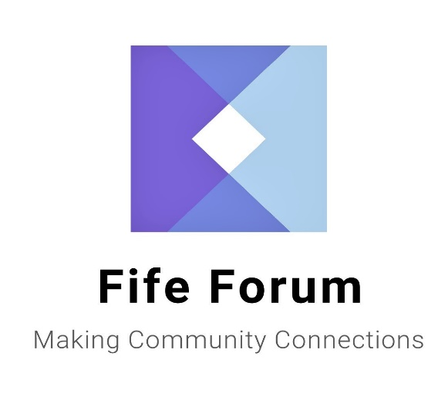

**SHOPPING DELIVERY**

**&**

**DOMESTIC SERVICE PROVIDERS**

**+**

**OTHER USEFUL**

**INFORMATION**

**Fife Forum is the umbrella organisation for all elderly fora and user panels in Fife, offering information advice and advocacy for older people.**

The information contained in this booklet is provided as a guide for people who may require a shopping delivery or cleaning service to assist them with their daily living.

Along with this information are details of some other organisations that may be of use to you.

This is general information to assist you only. No organisation mentioned is endorsed by Fife Forum

**Pricing may change please check with the provider.**

**Ageless Companions 01592 396326**

**or 07728 596126**

**Rate**

Shopping Delivery Service £17.95 per hour for all services

Prescription Collection Service

Post Office Services

Befriending/Companion Service

**Area Covered**

Fife Wide

**Discloser Checked**

Yes

**Staff will assist with completion of shopping lists and putting the groceries away.**

**Staff will assist the client in light housekeeping duties during their Companion hours.**

**Mileage is calculated at 50p per mile. Mileage is paid only when Companion is with the client.**

**An invoice is issued every 4weeks. Payment can be made by BACS transfer, Credit/Debit card or cheque.**

**All staff have had Adult Protection Training; Covid-19 Awareness Training and are Dementia Friends having undertaken Dementia Awareness Training.**

**Assisted Services 07549982245**

**0r 01592 775261**

**Rate**

Personal Care £18.88 per hour Monday-Friday

£23.67 per hour Saturday-Sunday

**Area Covered**

West Fife

**Disclosure Checked**

Yes

**We strive to provide Care and Support in a manner which respects the privacy, dignity and wishes of service users.**

**Payment can be made by cash or cheque.**

**Avenue Care Services 01383 326401**

Rate £20.00 per hour

Domestic Cleaning

Shopping Delivery

Prescription Collection Service

**Area Covered**

Fife wide except St Andrews

**Disclosure Checked**

Yes

**General household duties including Laundry and Bed changing.**

**Payment by Direct Debit, Standing Order, Cash or Cheque.**

**Bloomin’ Braw (Garden Maintenance) 07393 411430**

**Rate**

Jobs are completed to a high standard at reasonable prices. All services come with a smile. Call Dylan now to book your personalised and free, no obligation quotation.

**Area covered**

Bloomin’ Braw is a garden maintenance service, based in Benarty, Kirkcaldy, Dunfermline; and anywhere in between.

**PVG Checked**

Yes and Dylan has experience working with elderly and vulnerable people.

Payment can be made either with cash or bank transfer.

**Blue Star St Andrews Ltd 07967025121**

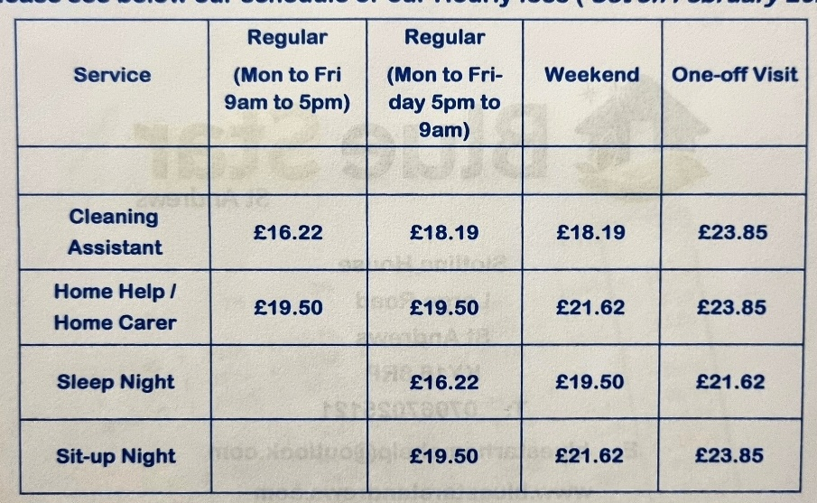

**Area Covered**

St Andrews and surrounding area, East Neuk villages and Howe of Fife.

**Disclosure Checked**

Yes

**Constance Care 01592 577555**

**Rate**

Personal Care Only £18.88 per hour Monday – Friday

£23.87 per hour Saturday - Sunday

**Area Covered**

Glenrothes, Kirkcaldy and Levenmouth, Dalgety Bay.

**Disclosure Checked**

Yes

**Personal Care/Sitting Service/ Social Visits/Escort Services also available contact them direct for further information.**

**Caroline Inch 07593416528**

**Rate**

£25.00 Footcare Services only.

**Area Covered**

Kirkcaldy, Dunfermline & surrounding area.

Possible mileage charge.

**Disclosure Checked**

Yes PVG

**Central Fife Companions 07956666275**

**Rate**

£16.00 per hour for all services.

Shopping Service, Prescription Collection, Post Office Services,

Befriending/Companion Service

Mileage Charge £0.50p per mile.

**Area Covered**

Fife Wide

**Disclosure Checked**

Yes

**Connected Care Services 01592 781888**

We only provide personal care packages.

**Rates**

Mon-Fri £20.00 per hour

Weekends £23.00 per hour

Increased rates for Bank/Public Holidays.

Travel is 25 pence per mile.

**Disclosure Checked**

Yes

**Crisscross Companion 01333 279328**

**Or 07580006161**

**Rate**

From £13.50 per hour.

Shopping Service, Appointments i.e. Doctor, Hospital, Chiropody and Hairdresser. Staff will assist in light Housework.

**Area Covered**

North East Fife, St Andrews & East Neuk.

Mileage charge of 55p per mile.

**Disclosure checked**

Yes PVG

**Domestic Matters 07901 595854**

**Rate**

Domestic Cleaning £22.00 per hour

**Area Covered**

Dunfermline through to Leven

**Disclosure Checked**

Yes

**Will also provide oven cleaning and one-off cleaning service.**

**Elite Care Scotland 01334 476262**

**Rate**

£22.00 per hour Monday – Friday

£23.32 per hour Saturday – Sunday

£17.61 per hour Sleepover

Only personal care packages.

**Area Covered**

Fife Wide

**Disclosure Checked**

Yes

**For a full range of services please contact direct**

**Fife Shopping and Support Services 01592 653344**

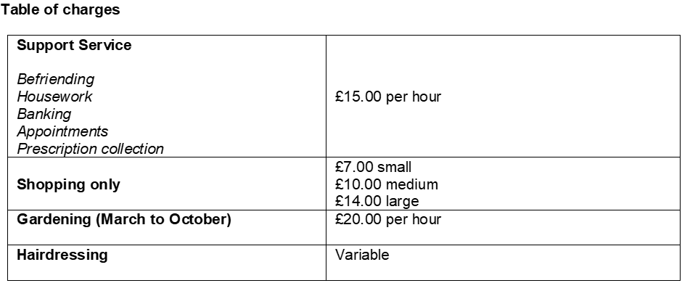

There is a charge for mileage from home to home at 45p a mile and you will be required to pay for any meals or refreshments whilst out.

**Area Covered**

Fife Wide

**Disclosure Checked**

Yes

**Staff will assist with completion of the shopping lists and putting the groceries away.**

**Payment by cash or standing order.**

**Charity Registered. SC042624 Not for profit organisation.**

**First Domestic Ltd 01383 736922**

**Or 0774 508 5970**

**Rate**

Shopping Delivery £6.00

Prescription Collection £3.00

Pension Collection £3.00

Post Office Services £3.00

Domestic Cleaning £10.00 per hour

**Area Covered**

Dunfermline, Carnock, Cairneyhill, Hill of Beath & Oakley

**Disclosure Checked**

Yes

**Service available 24 hours 7 days a week contact direct for any additional information**

**Guardian Peace of Mind Services 07462 237437**

**Rate**

Shopping Delivery Service £18.00 per hour

Cleaning, cooking, property maintenance, decorating, gardening, DIY & companionship £18.00 per hour

**Area Covered**

Dunfermline and surrounding area.

**Disclosure Checked**

Yes

**Payment is by direct debit.**

**Got it Covered 07581367278**

Domestic Cleaning – Dusting, Hoovering, Cleaning inside of windows, Kitchen and Bathrooms cleaned, all general cleaning duties.

**Rate** £15.00 per hour

**Area Covered**

Cowdenbeath, Dunfermline & Rosyth

**Disclosure Checked**

Yes

**Payment by cheque or standing order.**

**Jill of All Trades 07990807478**

**Rate**

Flat rate of £17.50 per hour charged. £9.00 per half hour.

**Area Covered**

North East Fife (Wormit based).

**Disclosure Checked**

Yes

Companionship or outings, shopping, meal preparation, hospital/dentist and GP appointments. Medication prompts, dog walking/pet care, storage solutions.

**Payment by cash, cheque or bank transfer.**

**Jolly Happy Feet 07882859479**

Nail cutting and pedicure/manicure service.

Prices on request. Dunfermline area.

**Karen’s Chores 01383 831103**

**Rate**

Domestic Cleaning £13.00 per hour

**Area Covered**

Kelty, Cowdenbeath and Dunfermline

**Disclosure Checked**

Yes

**Clients must supply their own cleaning materials**

**Kenylink Services Ltd 01592 651650 or 07846032164**

**Rate**

Cleaning £17.64 per hour

**Area Covered**

East, West and Central

**Disclosure Checked**

Yes

**Contact direct for further information**

**Oran Homecare Ltd 01334 652987**

**Rate**

Shopping Delivery £26.00 per hour

Domestic Cleaning £26.00 per hour

**Area Covered**

Fife Wide

**Disclosure Checked**

Yes

**Mileage rates may apply for outlying clients.**

**Staff will assist with completion of the shopping lists and putting the groceries away.**

Payment can be made using various methods.

**Disclosure Checked** Yes

**Shine Time Cleaning 01592 569851**

**Or 0751 890766**

**Rate**

Shopping Delivery £15.00 per hour

Prescription Collection £15.00 (min 1 hour)

Cleaning £15.00 per hour (min 1 hour)

Carpet Cleaning from £25.00

Oven Cleaning from £45.00

Ironing, window cleaning, changing beds etc. also available.

A £0.20p per mile mileage charge may apply out with Kirkcaldy

**Area Covered**

Central Fife

**Disclosure Checked**

Yes

**Staff will assist with completion of the shopping lists and putting the groceries away.**

**Contact direct for any further information.**

**Spotless Team 07989 301521**

**Rate**

£16.00 per hour for one off clean

£14.00 per hour for regular cleaning

Washing and shopping service can also be provided.

**Area Covered**

St Andrews and surrounding area including Anstruther, Crail, Cupar, Drummoig & Strathkinnes

**Disclosure Checked**

This is a family business; the husband and wife are disclosure checked 2 other family members are not.

**The Good Care Group Scotland 0131 3413 654**

**Rate**

From £1569 per week (70 hours of care).

Provision of 24 hour live in care in your own home, providing you have a separate room for Carer.

**Contact direct for any additional information**

**RVS Good Neighbours 01592 269654**

**Rate**

£4.00 for first 3 miles and £0.60 for every other mile to cover cost of transport.

**Area Covered**

Fife Wide

**Disclosure Checked**

Yes

**They will only provide a one to one escorting service to the shops.**

**The following pages list other organisations that you may find useful to you.**

|  |  |  |
| --- | --- | --- |
| **Name** | **Telephone Number** | **Email No / Text Phone / Website** |
| Advocacy for Older People in Care Homes & Community Hospitals (FF) | **01592 643743** | Specifically for older people who are either resident in a care home or who are patients in a community hospital and meeting the eligibility criteria. |
| Age Scotland Advice – Scottish Helpline for Older People | **0800 12 44 222** | Text phone: **0845 226 5851** |
| Age UK | **0800 678 1174** |  |
| Alzheimer Scotland Dementia Helpline | **0808 808 3000** |  |
| Attendance Allowance | **0800 731 0122** | Text phone: **0800 731 0317**  Website: [www.direct.gov.uk/pensions](http://www.direct.gov.uk/pensions) |
| Blue Badge Renewal | **03451 55 00 66** |  |
| British Red Cross | **07922 584616** |  |
| Bums Off Seats – Fife Walking Initiative | **03451 555 555**  **Extension 402443** | Email: [vivienne.mcniven@fife.gov.uk](mailto:vivienne.mcniven@fife.gov.uk) |
| Carers Scotland | **0808 808 7777** |  |
| Carpet Queen | **07597**  **057121** | Carpet & Domestic Cleaning |
| Circles Network – Professional & Independent Advocacy Service providing issue-based Individual and Collective Advocacy Support | **01592 645360** |  |
| Citizens Advice & Rights Fife | **0345**  **1400 095** |  |
| Contact the Elderly in Scotland | **01505 874412** |  |
| Cruse Bereavement Care Scotland | **0808 802 6161** | [www.crusescotland.org.uk](http://www.crusescotland.org.uk) |
| Deaf Communication Services – Fife Council | **08451**  **55 0000** | Minicom 01592 583265  SMS 07984 356580 |
| Disability Living Allowance | **0800 121 4600** | Text phone: **0800 121 4523**  Website: [www.direct.gov.uk/pensions](http://www.direct.gov.uk/pensions) |
| Disabilities Fife | **01592 203993** | Mobile: SMS Text 07841504318  Email: [chair@disabiltiesfife.org.uk](mailto:chair@disabiltiesfife.org.uk) |
| Energy Saving Scotland Advice Centre | **0800 710 1016** | Email: [energyadvice@changeworks.org.uk](mailto:energyadvice@changeworks.org.uk) |
| Energywatch | **0800 710 1016** |  |
| Fairprice Mobility Scotland | **01592 652244** | Disability Equipment (Manufacturers & Suppliers) |
| Fife Bus | **03451 55 11 88** | This is a free shopping service, medical appointment service & personal care appointment service for people who have difficulty using conventional public transport. Trained staff pick up passengers from their doors who are then driven to one of a choice of Town Centre destinations. For further information on how to use this service please contact the number provided. |
| Fife Adult Support & Protection | **01383 602200** |  |
| Fife Carers Centre | **01592 205472** | Email: [centre@fife.carers.net](mailto:centre@fife.carers.net) |
| Fife Care & Repair | **01592 632592** | Email: [careandrepair@kingdomhousing.org.uk](mailto:careandrepair@kingdomhousing.org.uk) |
| Fife Cares – Home Safety | **03451 551503** | Email: [admin.fifecares@fife.gov.uk](mailto:admin.fifecares@fife.gov.uk) |
| Fife Centre for Equalities | **01592 645310** | Email:  info@centreforequalities.org.uk |
| Fife Council Money Advice | **03451**  **55 00 44** | Email: [money.advice@fife.gov.uk](mailto:money.advice@fife.gov.uk) |
| Fife Council Main Switchboard | **03451 55 0000** |  |
| Fife Council  Social Work Contact Cntre  Out of Hours | **03451 551503**  **03451 550099** | This is the number for all Social Work services.  17.00-9.00 am Mon to Fri, all weekend and public holidays |
| Fife Day Care Services Ltd | **01592 782889** | Email: [fifedaycare@gmail.com](mailto:fifedaycare@gmail.com) |
| Fife Dental Advice Line | **01592**  **226555** |  |
| Fife Forum | **01592 643743** | Email: [info@fifeforum.org.uk](mailto:info@fifeforum.org.uk)  Website: [www.fifeforum.org.uk](http://www.fifeforum.org.uk) |
| Fife Pakistan Assoc |  | Email: [fifepakistanassociation@yahoo.co.uk](mailto:fifepakistanassociation@yahoo.co.uk) |
| Fife Sensory Impairment Centre | **01592 644979** | Email: [info@fsbinsight.co.uk](mailto:info@fsbinsight.co.uk) |
| Fife Shopmobility |  | Glenrothes 01592 807102  Kirkcaldy 01592 803772  Dunfermline 01383 661455 |
| Fife Trading Standards | **01592 583141** |  |
| Fife User Panels | **01592 643743** | Email: [info@fifeforum.org.uk](mailto:info@fifeforum.org.uk) |
| Fife Voluntary Action | **0800 389 6046** |  |
| Footcare Fife | **0800 389 6046** | This service charges £10 for each appointment and covers the following areas: Buckhaven, Cupar, Dunfermline, Glenrothes, Kinghorn, Kirkcaldy & St Andrews  Email: [James@fifevoluntaryaction.org.uk](mailto:James@fifevoluntaryaction.org.uk) |
| Furniture Plus Ltd | **01592 654546** | Email: [enquiries@furnitureplus.org.uk](mailto:enquiries@furnitureplus.org.uk) |
| NHS 24 | **111** |  |
| Pension Credit /State Pension | **0800 731 0469** | Text phone: **0800 731 0464**  Website:  [www.direct.gov.uk/pensions](http://www.direct.gov.uk/pensions) |
| Police Scotland | **101** | Non-Emergency call**s** and business  Emergency calls **999** |
| Queen Margaret Hospital | **01383 623623** |  |
| Royal National Institute of the Blind | **0303 123 9999** | Text phone: **18001 0845 766 9999** |
| Scottish Fire & Rescue Service | **0800 0731 999** | Keep you and your loved ones safe from fire - get your free home fire safety visit today.  We'll help you sort out a fire escape plan and fit smoke alarms free of charge if your home requires them. |
| Seescape | **01592 644979** | For people with sight impairment |
| Shelterline | **0808 800 4444** |  |
| Silverline | **0804 4 70 80 90** | 24hr |
| Tax Help for  Older People | **0845 125**  **9732** |  |
| Tayport Old Peoples Club | **42 Elizabeth Street Tayport DD6 9LT** |  |
| Telephone Preference Service | **08450 70 07 07** |  |
| Trading Standards Service – Fife Council | **01592 583141** |  |
| U-Switch | **08453 45 12 96** |  |
| Victoria Hospital  Maggies | **01592 643355**  **01592**  **265851** |  |
| Will Writing Company | **0844 412 0776** |  |
| RVS–Good Neighbours Home Support Project | **01592 269654** |  |

**Anyone wishing further information or assistance with the information contained or information relating to the services of Fife Forum should contact us by writing to us at the address overleaf or by calling either of the Freephone numbers given.**



Office 1-2 Fraser Buildings

Millie Street

Kirkcaldy

KY1 2NL

Freephone 0800 032 4595

0800 032 4596

Email [info@fifeforum.org.uk](mailto:info@fifeforum.org.uk)

Website [www.fifeforum.org.uk](http://www.fifeforum.org.uk)

**Scottish Charity Number SC022596**

** MAY 2024**